[1] CSA-1560 CLOUD COMPUTING LAB PRACTICALS

6.Change Hardware compatibility of a VM (Either by clone/create new one) which is already created and configured.

Step-1:

First install VMware workstation on your pc/laptop. Then open the VM software and click create a new virtual machine displayed on a home tab.

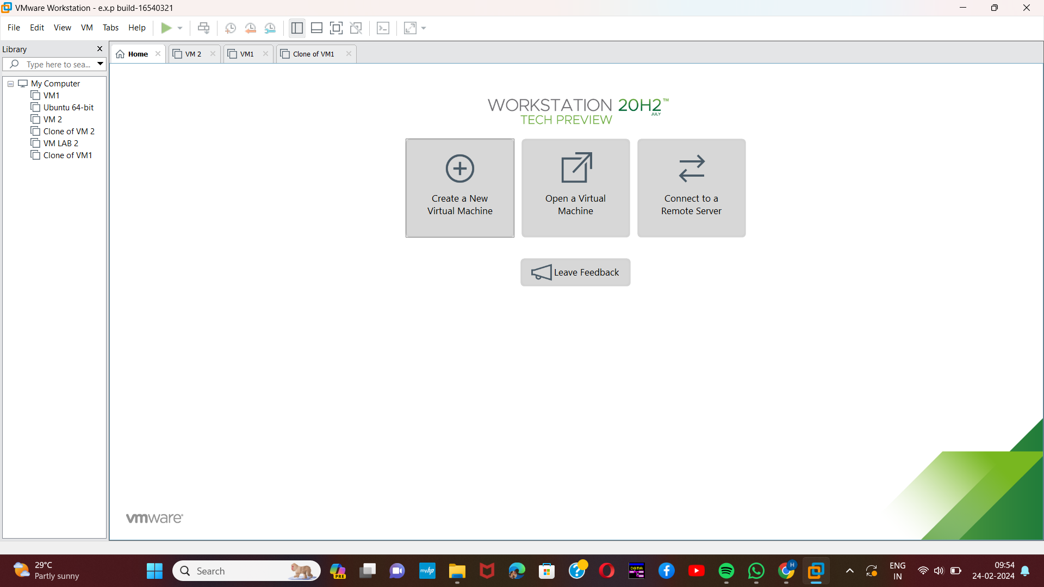

Step-2:

Here,we are going to Demonstrate virtualization by Installing Type -2 Hypervisor on your device, creating and configuring a VM image with a Host Operating system (Either Windows/Linux).so choose the second option and browse the location of the OS which needs to be installed.

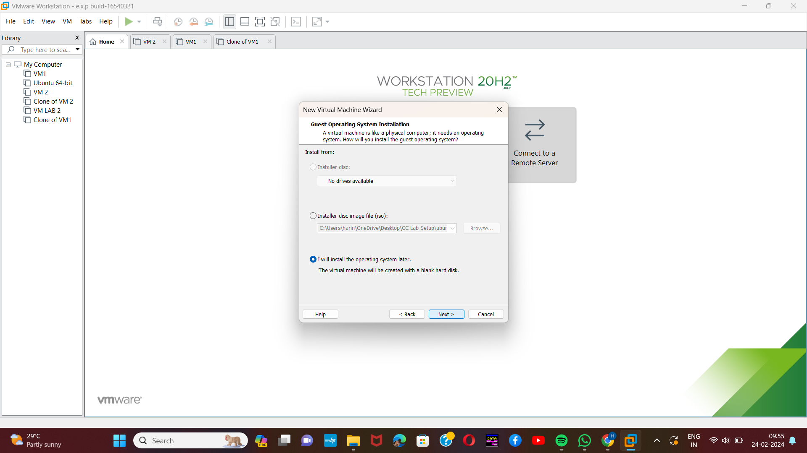[2]

Step-3:

Next step is to select any operating system from the given list.

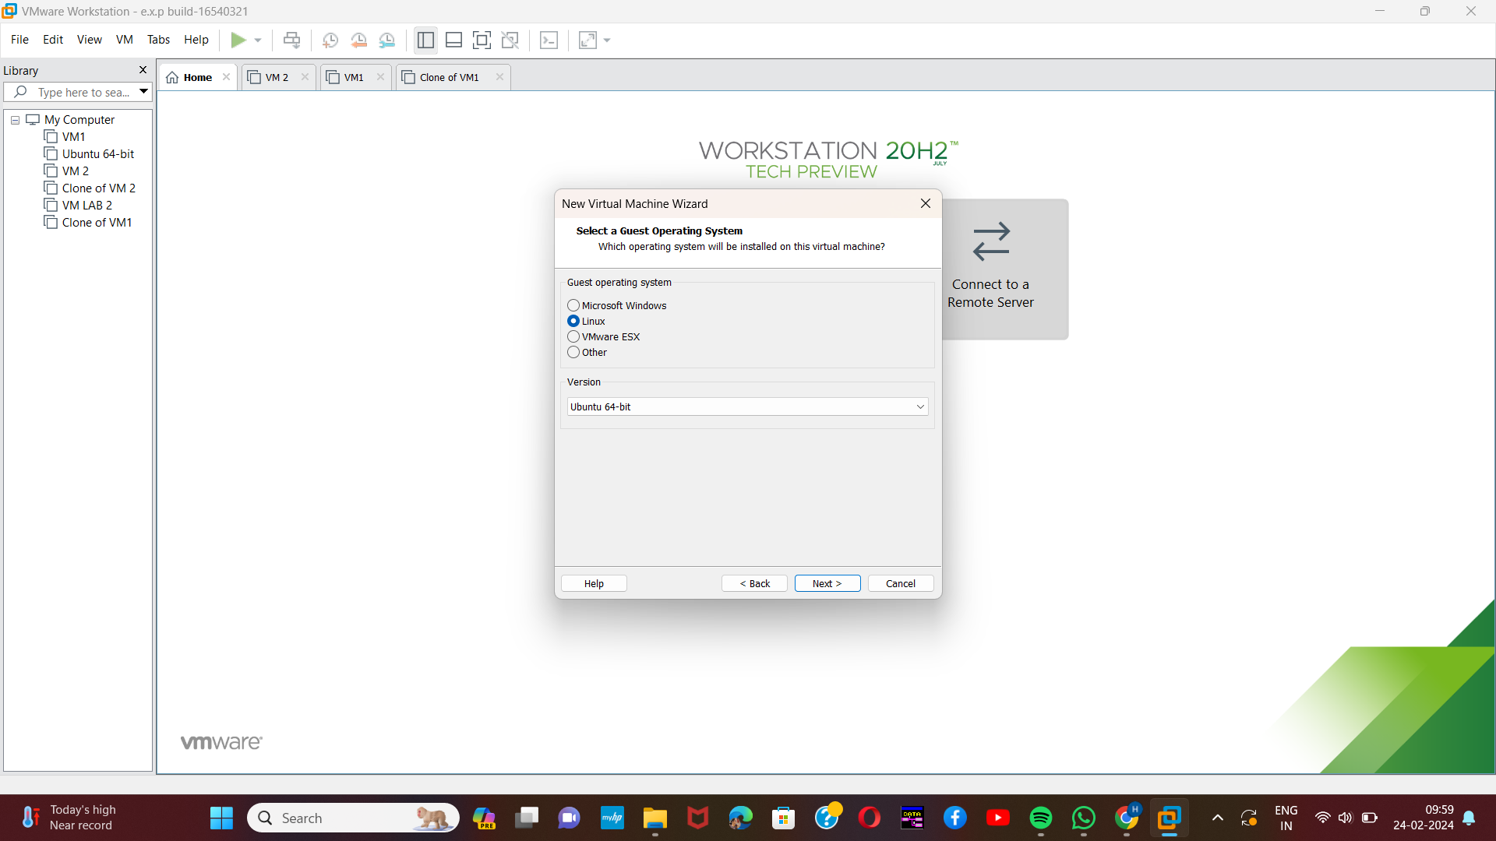

Step-4:

Next provide an appropriate name for the created virtual machine.

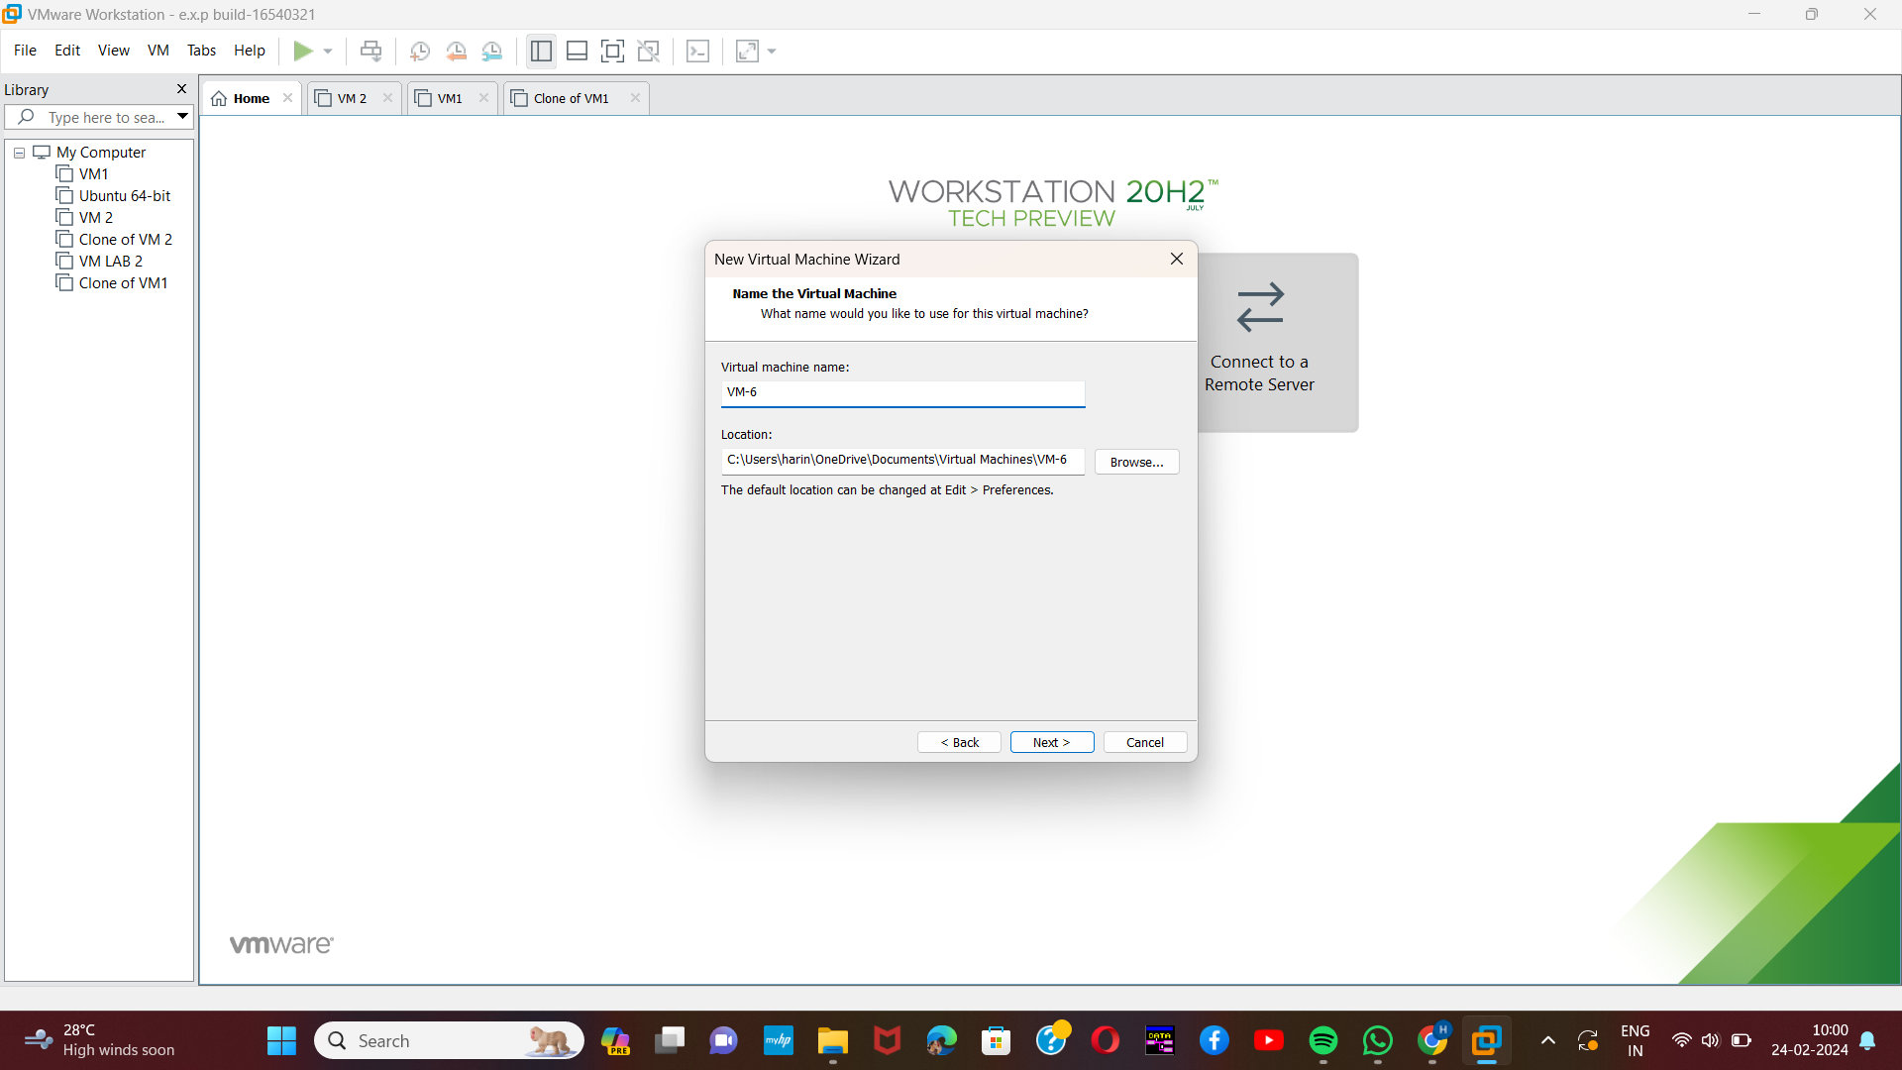[3]

Step-5:

Next, assign a specific disk capacity for the virtual machine created.

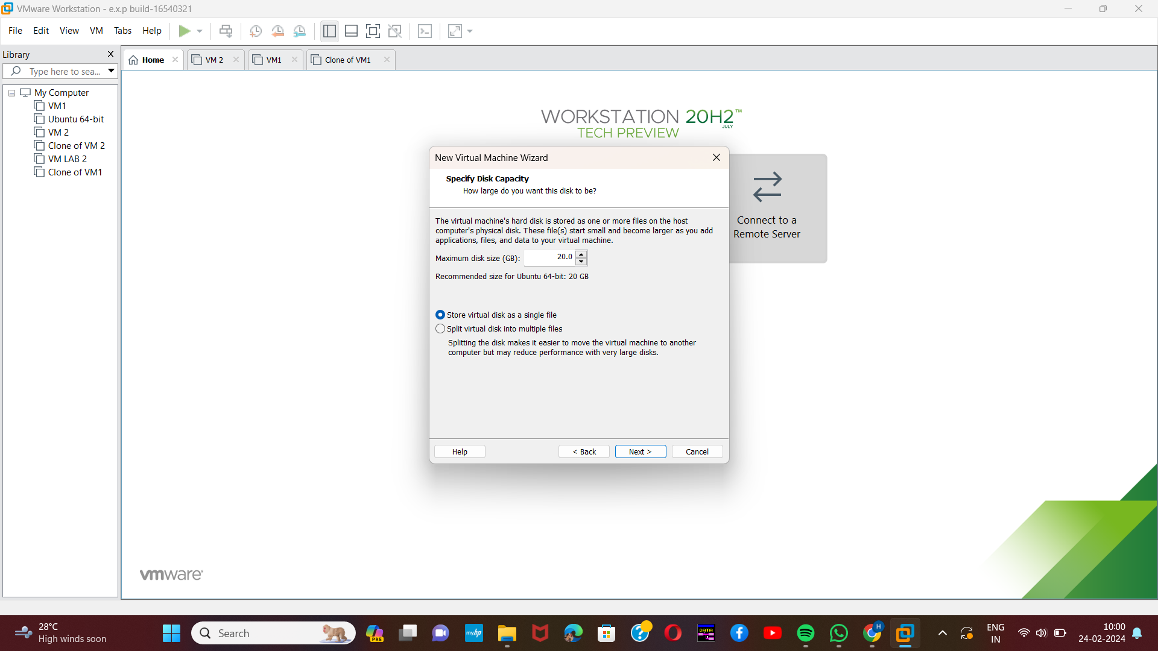

Step-6:

Now the virtual machine has been created with the specific disk which has been assigned to it.

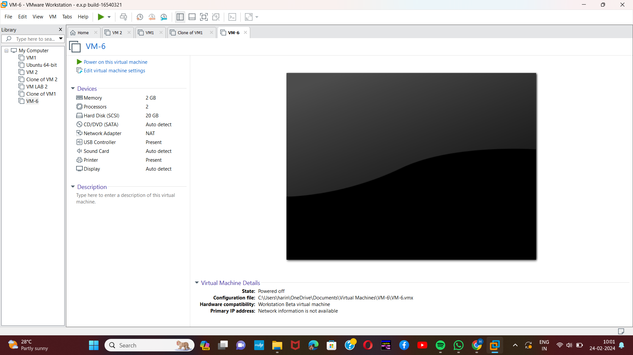[4]

Step-7:

Next change some of the hardware capabilities by changing the value of memory space.

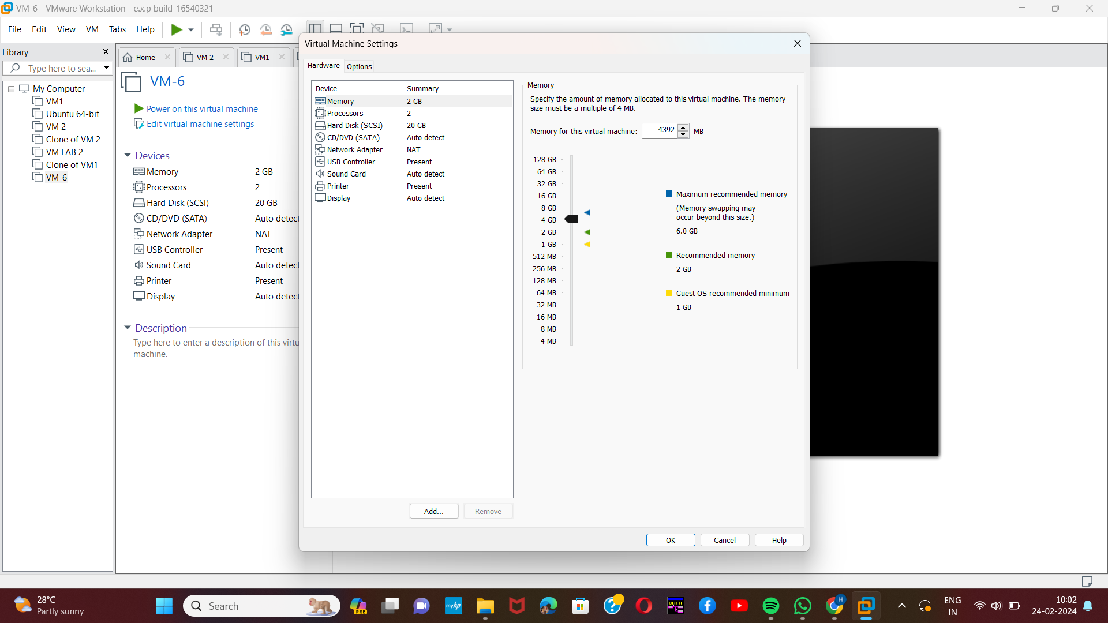

Step-8:

[5]Next change or alter the value of the processor which has been assigned to the virtual machine already.

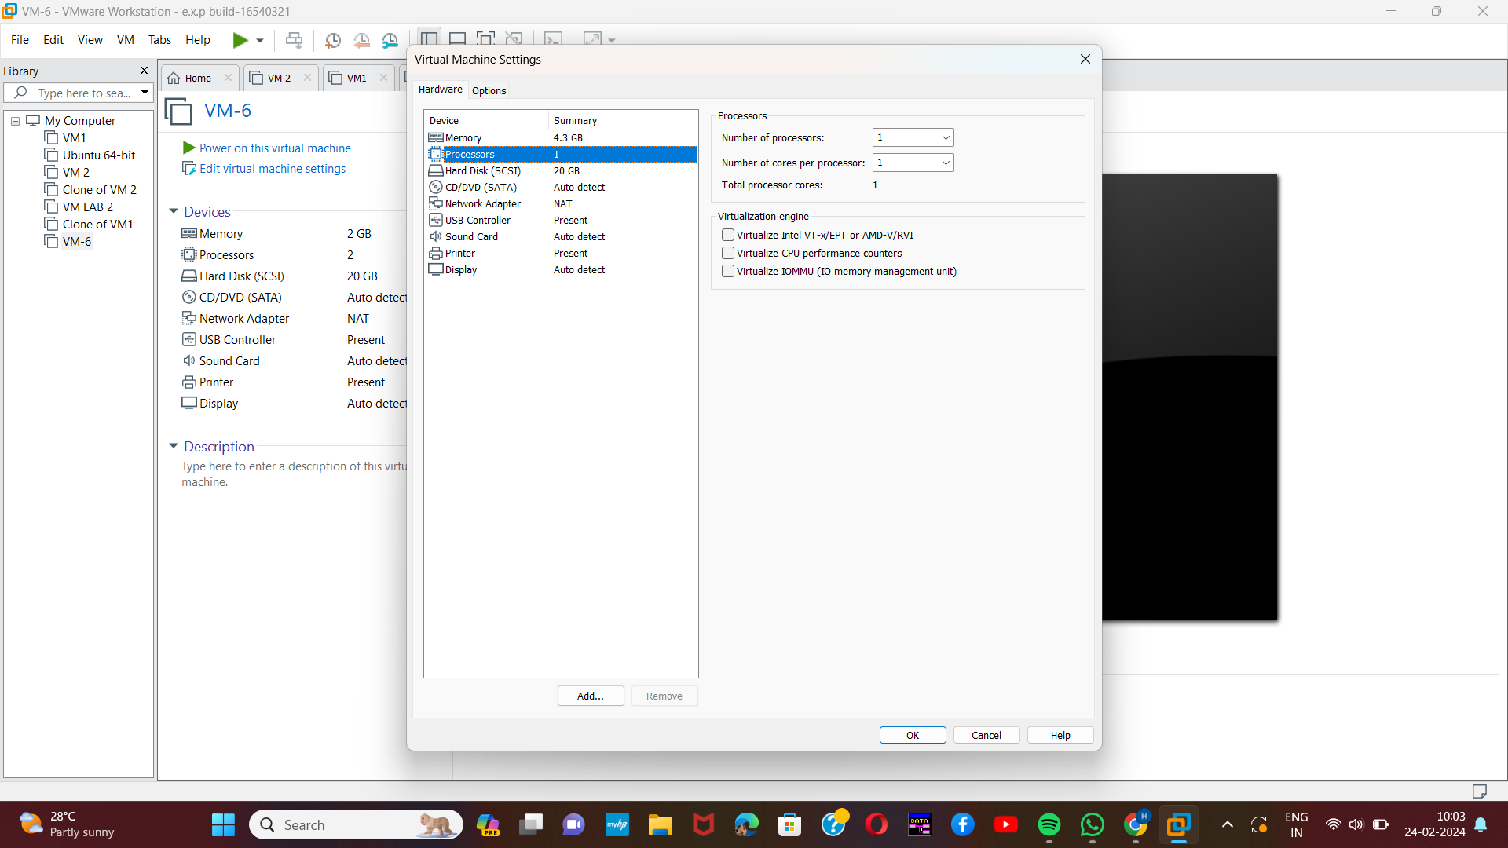

Step-9:

Now the changes had been made with the already created virtual machine by changing the hardware capabilities .

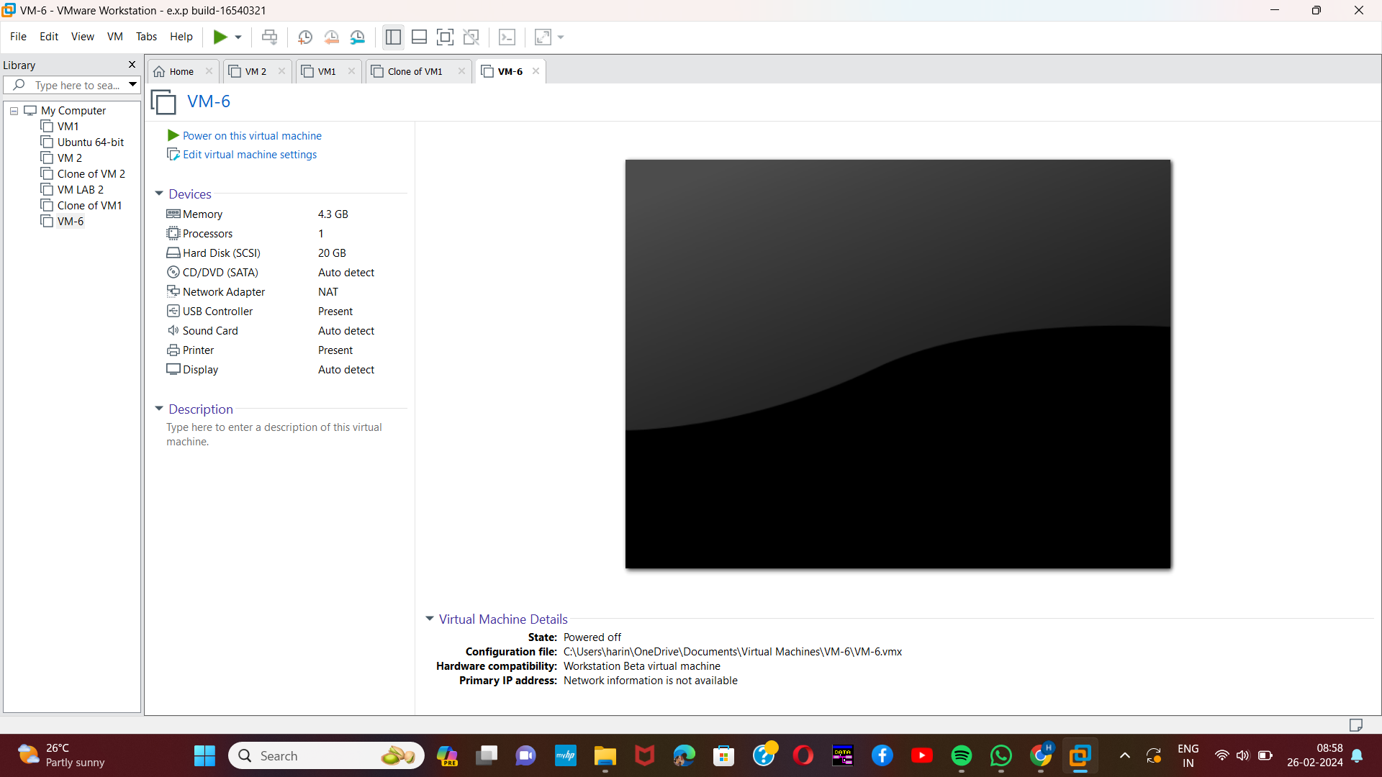[6]

1.
2.
3.
4.
5.
6.